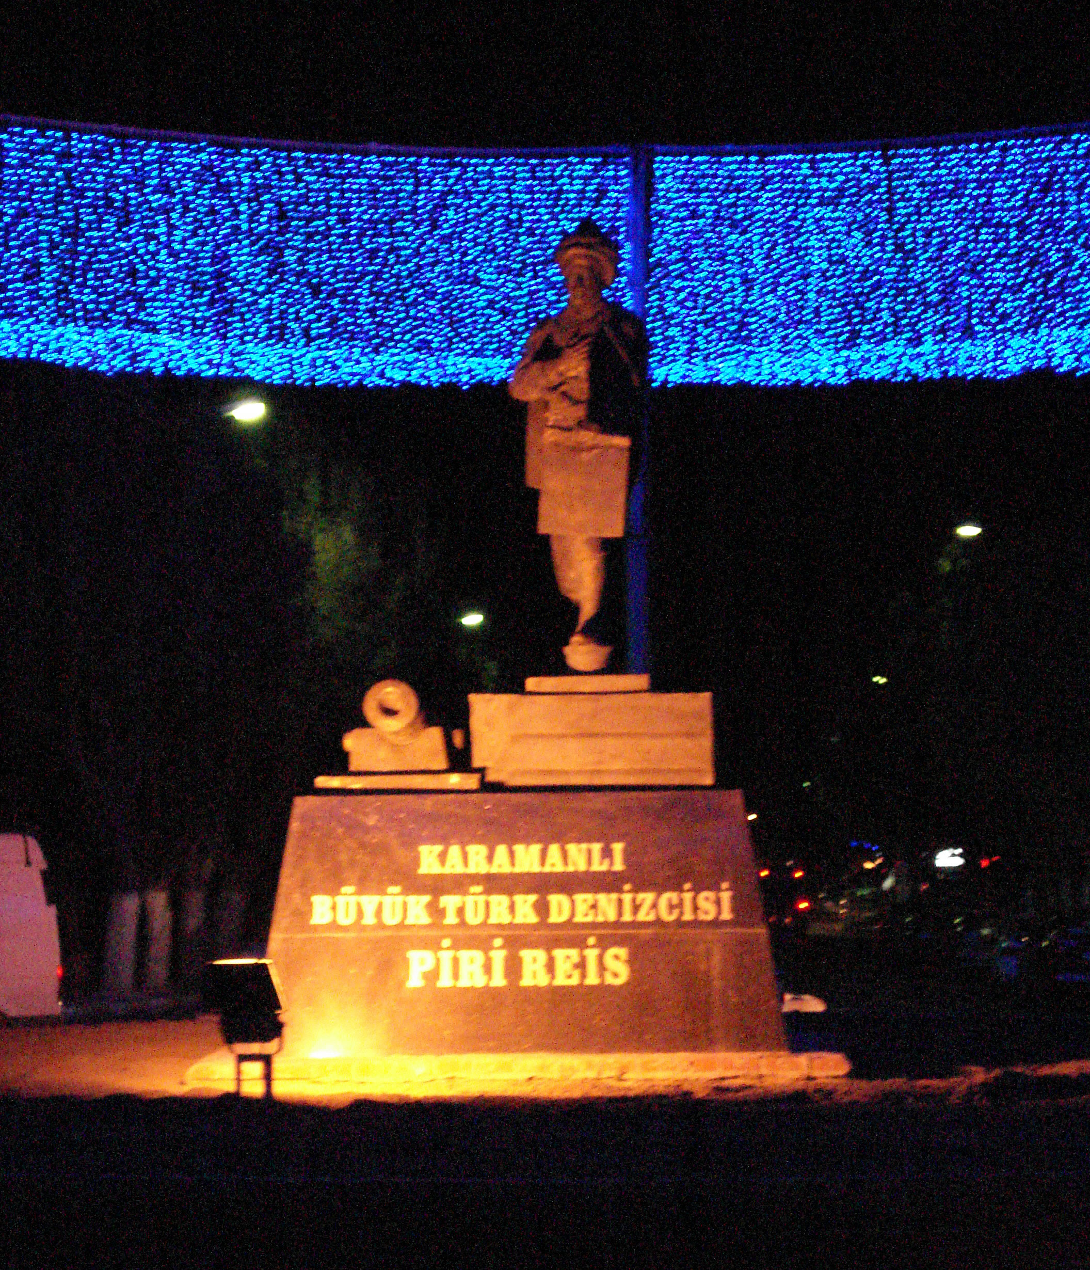

Partner request

Youth Exchange
-White Cities-

To whom it may concern,

It will take place between 24-30 september 2011.it will lasts 6 days.
The name in this year multilateral exchange is “White Cities ".the main topic is Environment because The light pollution which becoming an important environment problem and raising awereness of public about this subject. All the participants are going to share knowledge and ideas in questions and answer,furthermore we will visit the cities Konya another beautiful Turkey city and we organize different leisure facilities together.

The project addresses in the age of 16 to 25 from five different countries within Europe. There will attend 5 adolescents from each country in addition to one leader that amounts to 30 participants at total.

The youth education center functions as conference center and youth hostel. It provides political and experiential education for adolescents and adults. Additionally it organizes various projects and events.

$. We are looking for hosting and sending partner groups.

We will apply for the financial funds at the “Youth in Action” programme. If you are interested in participating please fill in part III of the “Youth in Action”- contact and sent it to us until the 20th of March.
When you have given us your assent, we will going to make the request and in March we will prepare the program for the youth exchange in cooperation with you.

Any Additional Information:

Type of the Project: Action 1.1 Multilateral
Our project is open to all program and partner countries but We want legal personality status participants for our project. The participants don’t demand visa cost. The travel costs don’t demand much than 400 euro.
We prefer experienced groups who attended youth exchange program onetime and we want to be hosted by them in their exchange projects.

We hope that you will pass this information to all relevant adolescents.

In terms of further enquiry please contact
Mustafa TOPÇU mailto:mustitopcu@hotmail.com

Post Adress: Mustafa TOPÇU
Şeyh Sadrettin Mahallesi Turgutoğlu Sokak No:24/4
42040 Meram/Konya TURKEY

Kind regards,

Mustafa

